| **BLOG-BYTE Progress File-7** |
| --- |

# **Tags API**

1. **Creating Tags**
2. **Using nprogress**
3. **CSS using static file and next-css**

**_______________________________________________________**

# **TASK-1 Creating Tags**

**STEPS :**

* In **backend,** go to **models** add **tag.js**.
* Creating Tag Schema.
* 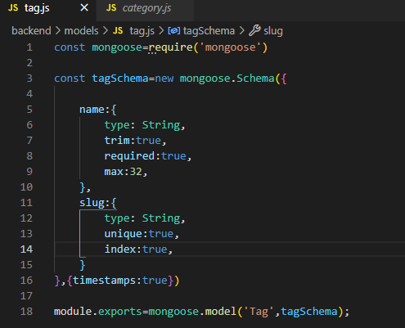
* Now go to **validators** add **tag.js**. Create validators here.
* 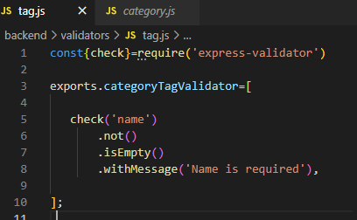
* Now go to **routes** add **tag.js**. Create routes here.
* 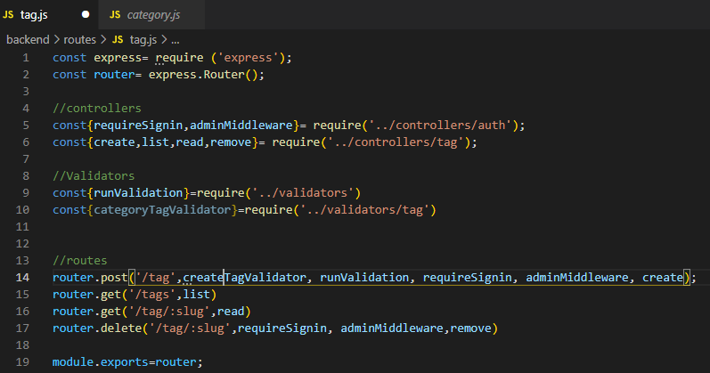
* Only admin can create a new tags.
* Adding routes in **server.js.**
* 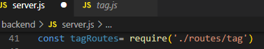
* Applying routes, as middleware.
* 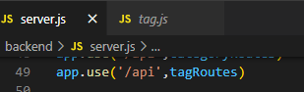
* Now go to **controllers** add **tag.js**. Create controllers here.
* 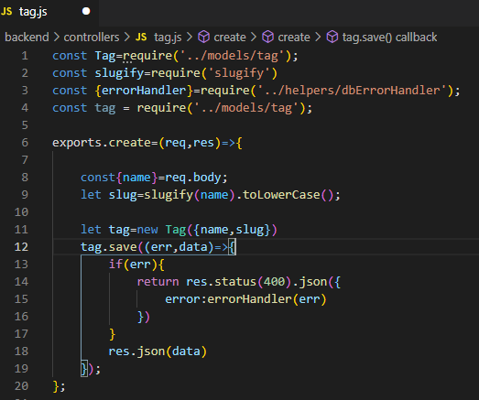
* Now adding methods in **tag.js** in **controllers**.
* All tags list, single category and delete tag.
* 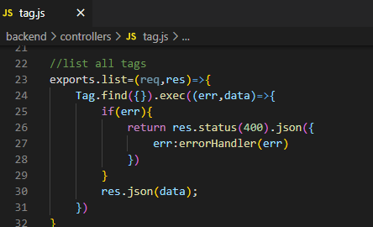
* 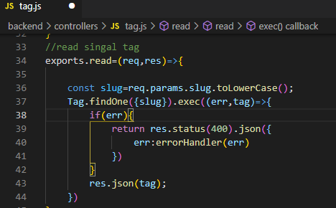
* 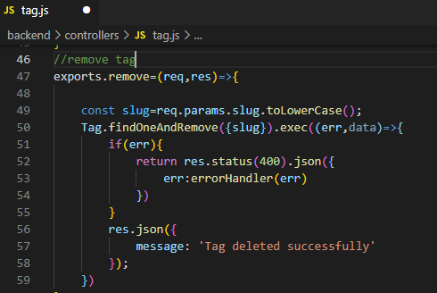
* Now try it on postman, make sure you are signin as admin.
* Create a new tag.<http://localhost:8000/api/tag>

|  |
| --- |

* Now try getting all tags. <http://localhost:8000/api/tags>

|  |
| --- |

* Now try to get a single tagusing slug in URL. [http://localhost:8000/api/tag/](http://localhost:8000/api/category/cat-three)react-tag .

|  |
| --- |

* Now make a DELETE request to delete category.

|  |
| --- |

* Now checking it deleted category exists, we will get null.

|  |
| --- |

* Now try creating same tag, and we will get error message properly.

|  |
| --- |

Tags Created in MongoDB Atlas.

|  |
| --- |

**=>Tags list, read ,delete ADDED, Task Completed… :)**

# **TASK-2 Using nprogress**

**STEPS :**

* To add progress bar, install package **npm i nprogress** in **frontend**.
* Go to **components**, **Header.js**, import nprogress.
* 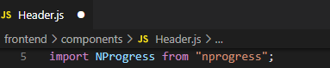
* Adding nprogress route methods.
* 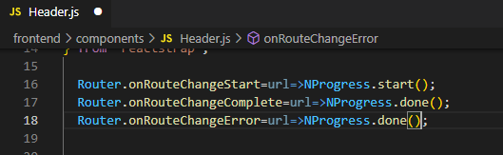
* Getting nprogress cdn.
* 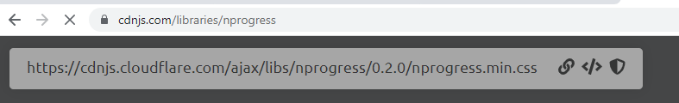
* Adding link in **pages** **_app.js**.
* 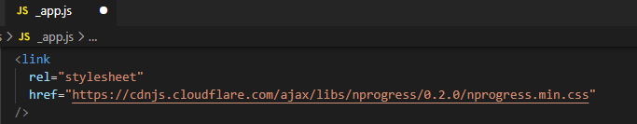
* Now run server go to any page and see progress bar running.

**=>Tags list, read ,delete ADDED, Task Completed… :)**

# **TASK-3**

# **CSS using static file and next-css**

**STEPS :**

* To add css, install package **npm i @zeit/next-css** in **frontend**.
* Go to **public, static** ,create new folder **css** and add new file **styles.css**, import nprogress.
* 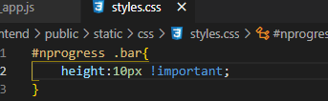
* To manually change nprogress bar css. G to node modules and open this file.
* 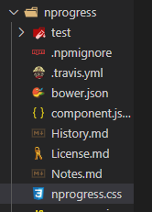
* Importing in **Header.js**.
* 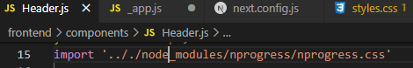
* Run the server and check progress bar working.

**=>CSS static file added,task Completed… :)**